



Team 6

Mobile Application Development

Project Topic : Audio Emotion Detection

Final Lab Evaluation

|  |  |
| --- | --- |
| ROLL NO | Name |
| CB.EN.U4CSE21301 | Aadithya E R Menon |
| CB.EN.U4CSE21342 | Pranav Sreerag |

Name of the Guide : Guruprakash Sir

**Model Comparison Table**

|  |  |
| --- | --- |
| **Model** | **Accuracy** |
| Gated Recurrent Unit(GRU) | 0.8819444179534912(88%) |
| Improved CNN-BiLSTM Hybrid Model | 0.9583333134651184(95%) |
| Multilayer Perceptron(MLP) | 0.9340277777777778(93%) |
| Graph Neural Network(GNN) | 0.8455(84.5%) |
| Convolutional Neural Networks(CNN) | 0.9444444179534912(94.4%) |

**Application architecture:**

1. **Gated Recurrent Unit (GRU)**

**Model summary**:

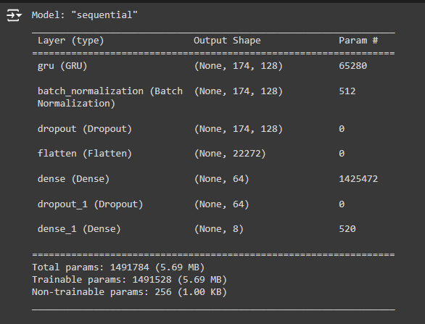

**Training and Testing**:

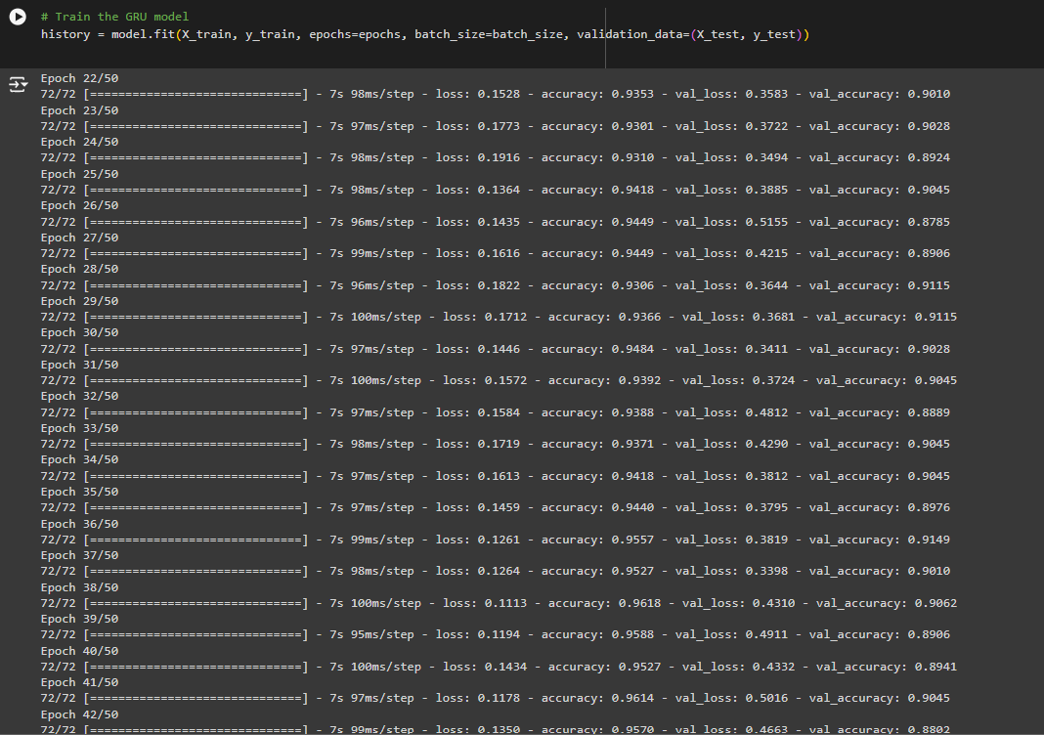

**Metrics**:

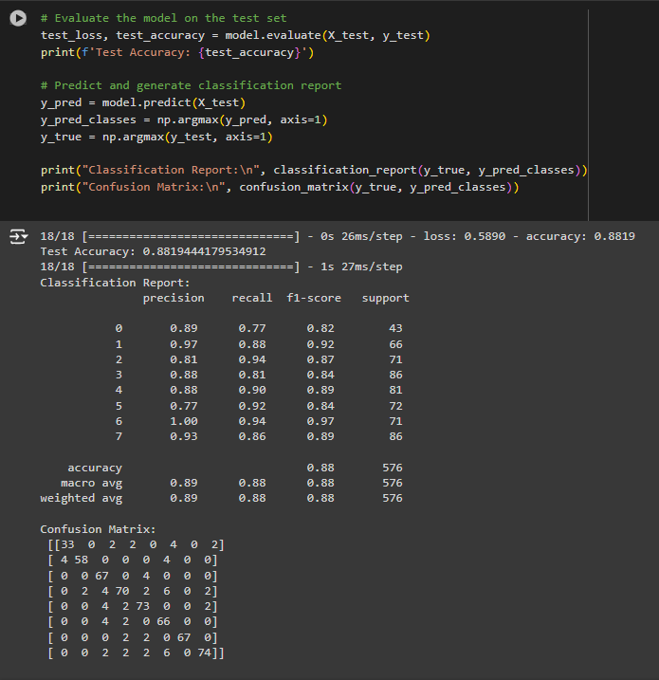

**Graphs and Plots**:

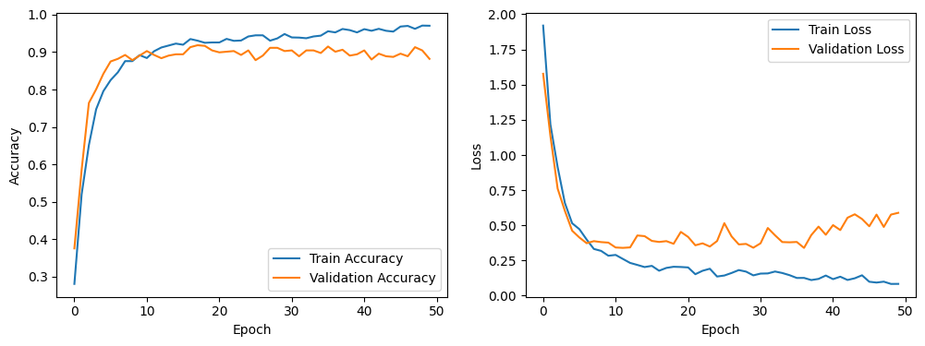

1. **Improved CNN-BiLSTM Hybrid Model:**

**Model training**:

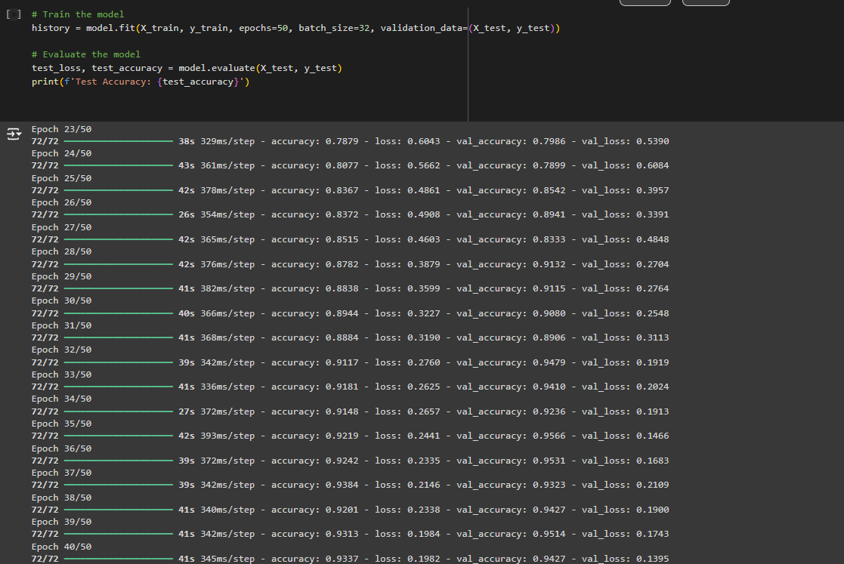

**Performance metrics**:

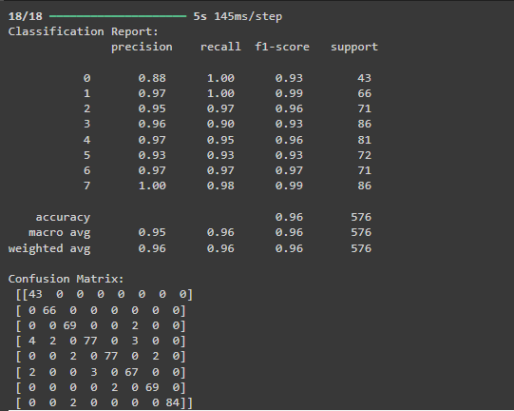

**Graphs and Plots**:

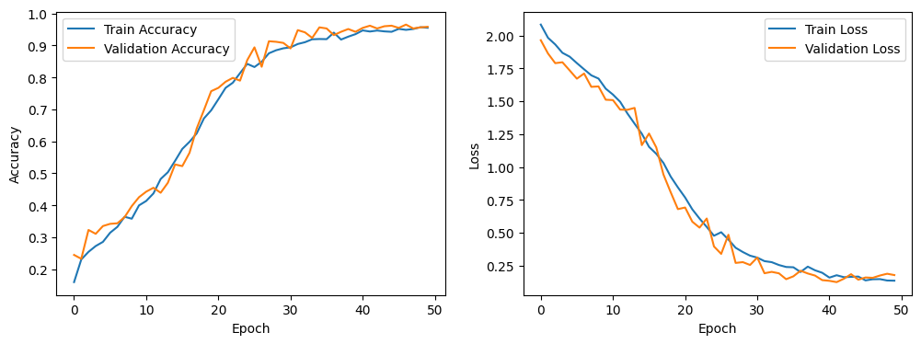

1. **Multi-Layer Perceptron(MLP)**

**Training the Model**:

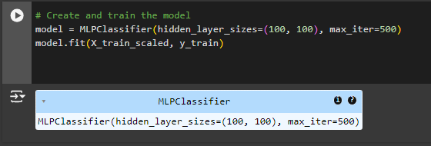

**Model Metrics**:

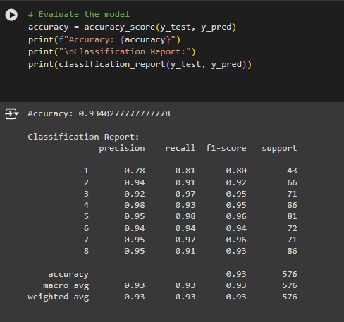

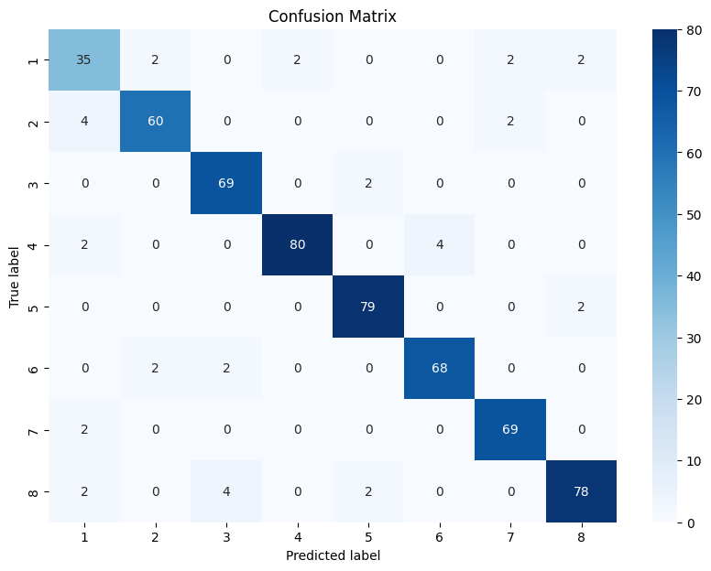

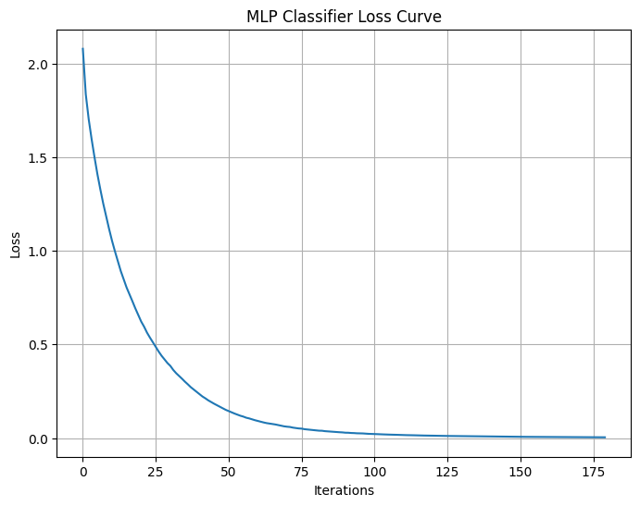

1. **Graph Neural Networks(GNN)**

**Training and testing the model**:

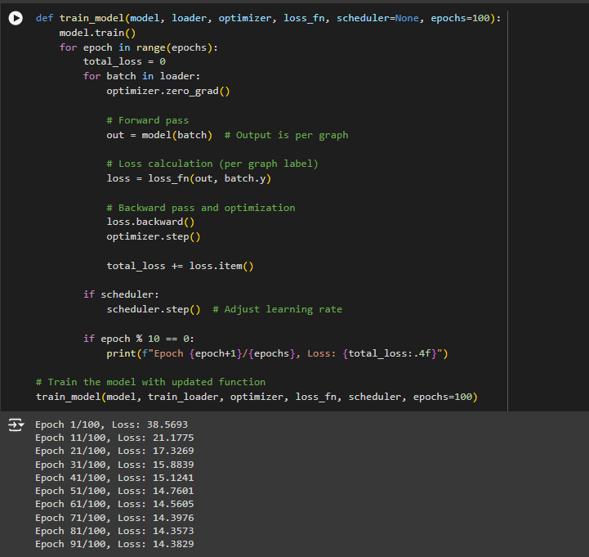

**Accuracy and Metrics**:

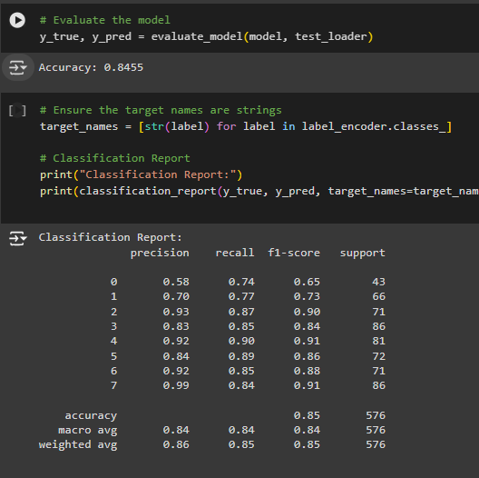

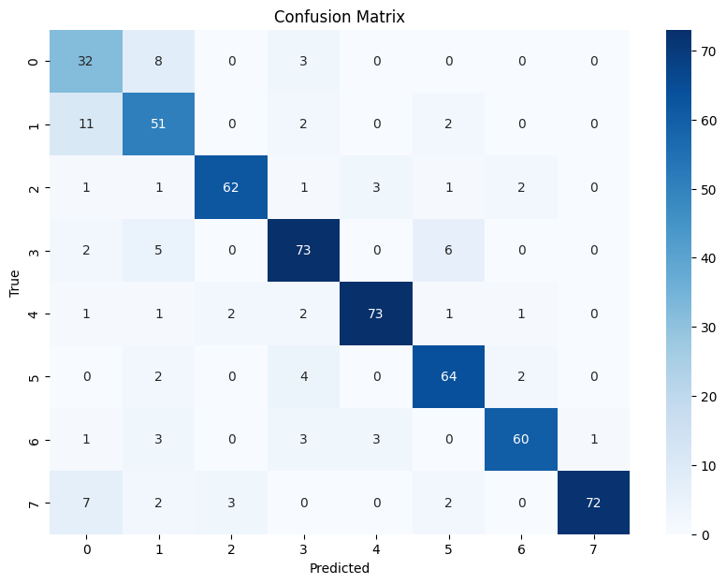

1. **Convolutional Neural Network(CNN)**:

**Model Summary**:

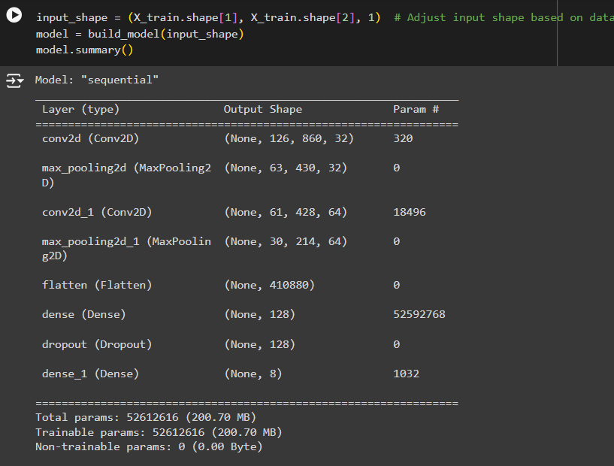

**Training and Testing**:

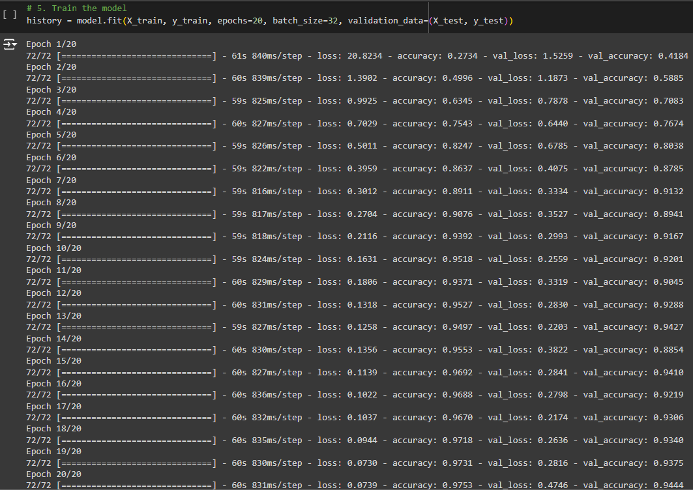

**Graphs and Plots**:

